Olivia Dopp
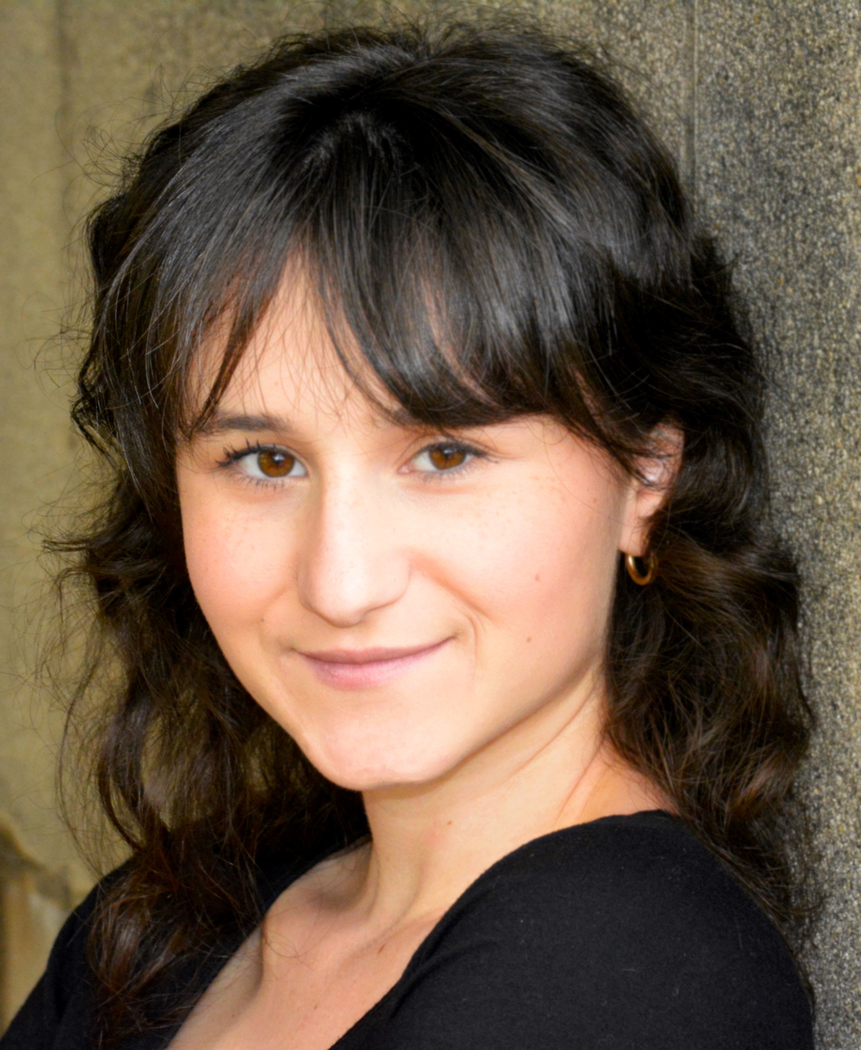
FILM
DUPLICATE | Lead | University of Southern California School of Cinematic arts Student Film / Dir. Catherine Johnson
MODERN LITTLE WEMON | Lead | USC SCA Student Film/ Dir. Vespera Luo  (602) 769-7579  dopp@usc.edu
AFTER SCHOOL GAMES  JACK & LOU | Supporting  Supporting | USC SCA Student Film / Dir. Lau Rodriguez  USC SCA Student Film / Dir. David Willner

THEATRE
THE WINTERS TALE | Dion/Dorcas | USC School of Dramatic Arts / Dir. Kate Burton
THE WHITE PLAGE | First Assistant | USC SDA / Dir. Ken Sawyer

TRAINING/EDUCATION
University of Southern California, BA in Theater with an Emphases in Acting and a Minor in Cinematic Arts
Acting, Movement, Voice, Advanced Shakespeare, Voice Over, Dubbing
Kate Burton, Rodney To, John DeMita, Gaby Santinelli

SPECIAL SKILLS
German, German accent, Swiss German accent, KonMari® CONSULTANT: licensed training for the Kon Marie method, Blowing Glass,

