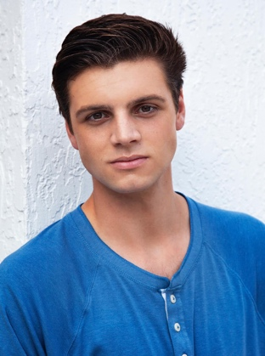
William Brown
(415) 699-6711
Wobster99@gmail.com

FILM
Cold Cuts | Supporting | USC School of Cinematic Arts / Dir. Sean Condie
The Destination  In Sync  Coalescent | Supporting  Supporting  Supporting | USC School of Cinematic Arts / Dir. Tony Huang  USC School of Cinematic Arts / Dir. Maddie Abiera  USC School of Cinematic Arts / Dir. Justin Guo
Roommate Wanted  William | Co-Star  Lead | Feature Film / Dir. Michael McCartney  Experimental Short Film / Dir. Nathaniel Dorsky

THEATRE
The Cider House Rules | Angel Wells | USC School of Dramatic Arts / Dir. Scott Farris
The Winters Tale | Florizel | Aeneid Theatre Company / Dir. Taylor Kass

TRAINING/EDUCATION
USC School of Dramatic Arts, BA – Acting
Acting: Joseph Hacker, Laura Flanagan, Rodney To
Voice: Brent Blair
London Academy of Music & Dramatic Art
Acting: Jenny Lipman
Movement: Vincent Manna

